27-6 Yahrzeit Wall Overview

The Yahrzeit Panels are etched glass panels with an automated lighting mechanism. These panels memorialize the names and dates of death of members of the congregation or their families.

In observance of individual Yahrzeit and Yizkor dates, memorial LEDs are lit and extinguished according to programmed synagogue policy, typically at the start of the Shabbat preceding the Yahrzeit. Yahrzeit and Yizkor dates may be based on either the Jewish or the secular (Gregorian) calendar. The memorial LED lighting time may be scheduled automatically, triggered manually, based on sunset, or set to a fixed time.

Manufacturer: On-Site Systems Inc. http://www.on-sitesystems.com
Yyz Systems Inc http://www.yyzsystems.com
Allan Schwartz (server and controller)

Model Number: custom installation

Maintenance: Clean the glass monthly, with Windex wipes or equivalent

Service: Glass – On-Site Systems
Electronics – Yyz Systems
Software – Allan Schwartz
Repair/reprint panels of glass – On-Site Systems

Location: Sanctuary west wall

Installers: On-Site Systems Inc. http://www.on-sitesystems.com
Gary Taylor gary@on-sitesystems.com 800-838-7778
Yyz Systems Inc http://www.yyzsystems.com
Marko Hajdinovic marko@yyzsystems.com 905-795-8500
Allan Schwartz allanschwartz@sbcglobal.net 669-350-7296

Physical Wall Overview

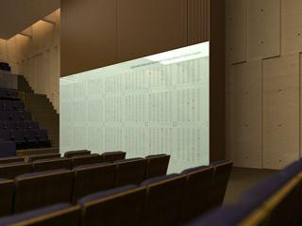

The Yahrzeit Wall comprises the Glass Panels (see section 27-7 Yahrzeit Panels), the embedded electronics in the wall, and the Yahrzeit Server software running on the Yahrzeit appliance or server (see section 27-8 Yahrzeit Server).

This document doesn’t discuss how the software operates, or is layered, or how the end-user interfaces with this software. See section 27-8 Yahrzeit Server.

This document doesn’t discuss the glass, or how to create or modify the panels. See section 27-7 Yahrzeit Panels.

Purpose of the System
The Yahrzeit System provides a browser-based interface for maintaining memorial records, configuring synagogue lighting policy, checking wall status, and operating the calendar-based Yahrzeit and Yizkor lighting schedule. The user interface is a set of browser pages, such as:
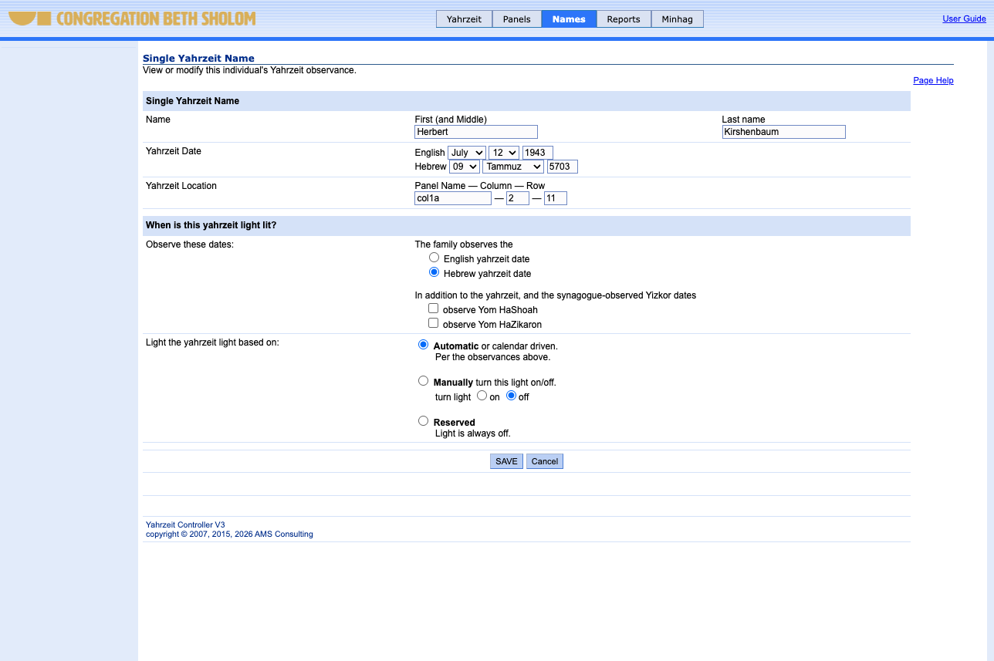

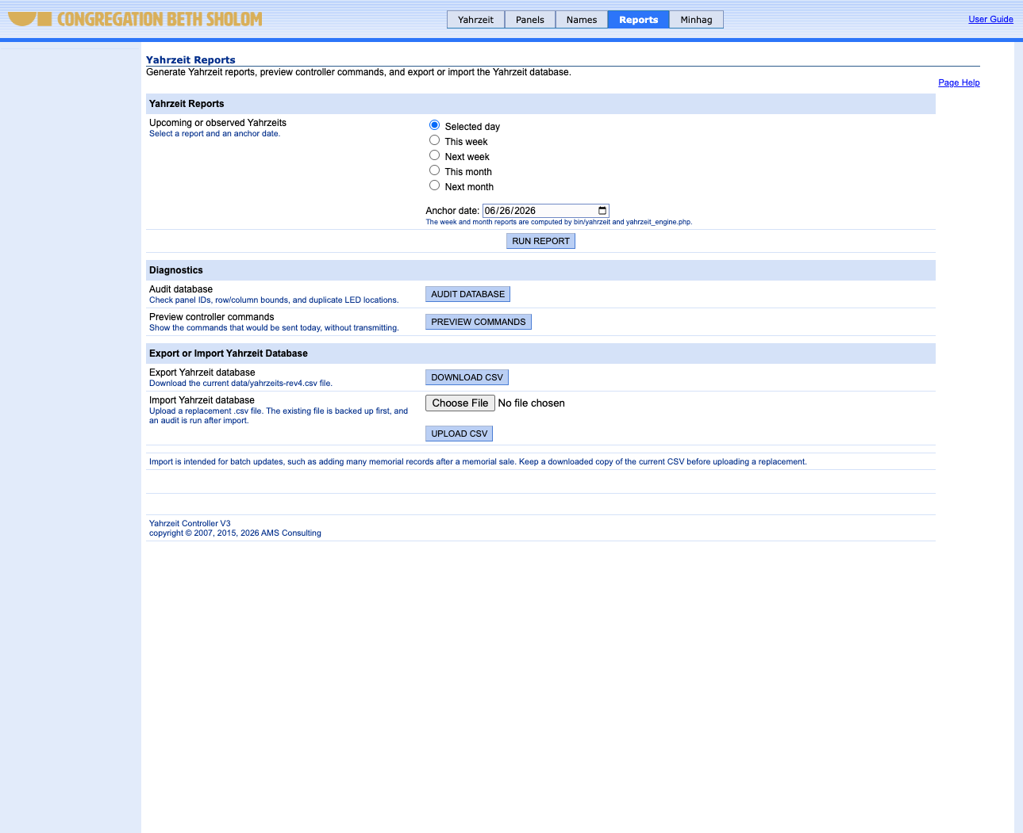

The Yahrzeit Wall Structure

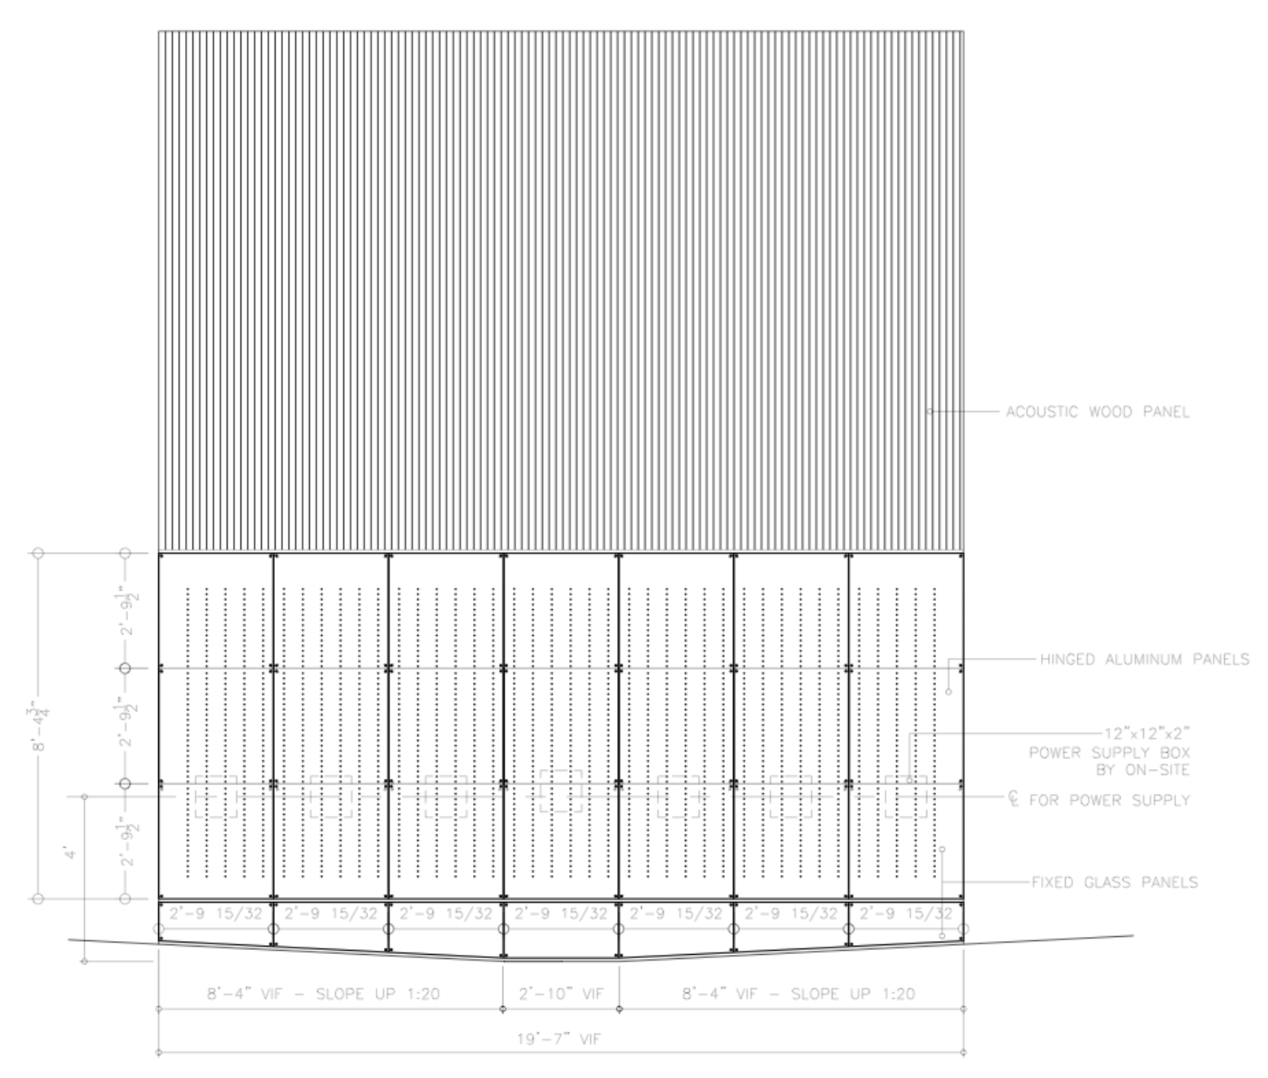

The Yahrzeit Wall Structure consists of seven large aluminum panels hinged at the top. Each aluminum panel supports three glass panels and has drilled openings through which the LEDs are visible. Circuit boards containing LEDs and supporting circuitry are mounted to the inside of the aluminum panels. Power supplies mounted inside the wall feed the LED circuitry.

The Yahrzeit Controller is an embedded microprocessor controller located behind the first large aluminum panel. It interfaces with the Yahrzeit LED Array and controls which memorial LEDs are lit.

The Yahrzeit Server resides in the synagogue office. It provides the browser-based user interface and runs the background processes that automate the Yahrzeit panels.

Yahrzeit Wall Components
This section briefly defines the components that make up the integrated Yahrzeit Wall.

Yahrzeit Panels –The twenty-one etched glass panels provide space for up to 2,240 names to be remembered.
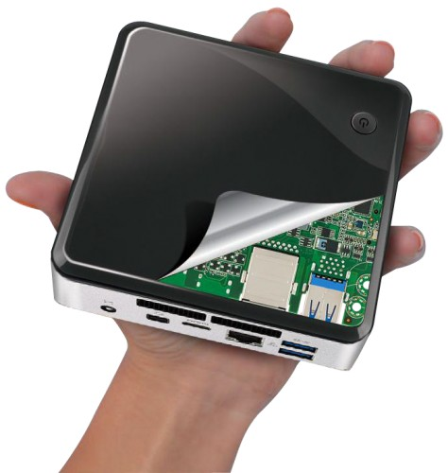

Yahrzeit Server – A Linux-based appliance that presents the browser user interface, runs the background processes that perform Yahrzeit and Yizkor automation, and signals the Yahrzeit Controller to change the LED display..

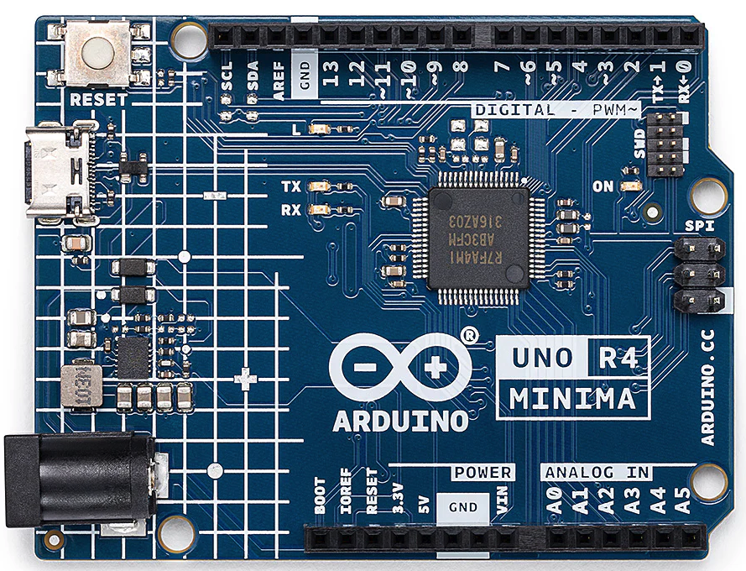

Yahrzeit Controller – The Arduino-based embedded controller installed behind the Yahrzeit Wall. It receives commands from the Yahrzeit Server and drives the Yahrzeit LED Array by refreshing the pixel boards with the current LED state.

Yahrzeit LED Array – The 56-row by 40-column LED array, for a total of 2,240 individual memorial LEDs.

Yahrzeit Pixel board (YPX) – The YPX board is a small number (6 or 8 or 10) of pixels or LEDs on a single printed circuit board. A string of 7 YPX boards comprise each column of 56 LEDs and 40 columns – a total of 280 YPX boards – are connected forming the entire LED array.

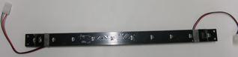

Interconnect cables – The Yahrzeit Pixel boards are interconnected in strings of seven YPX boards for each 56-LED column. Separate power interconnects distribute power to the pixel boards.

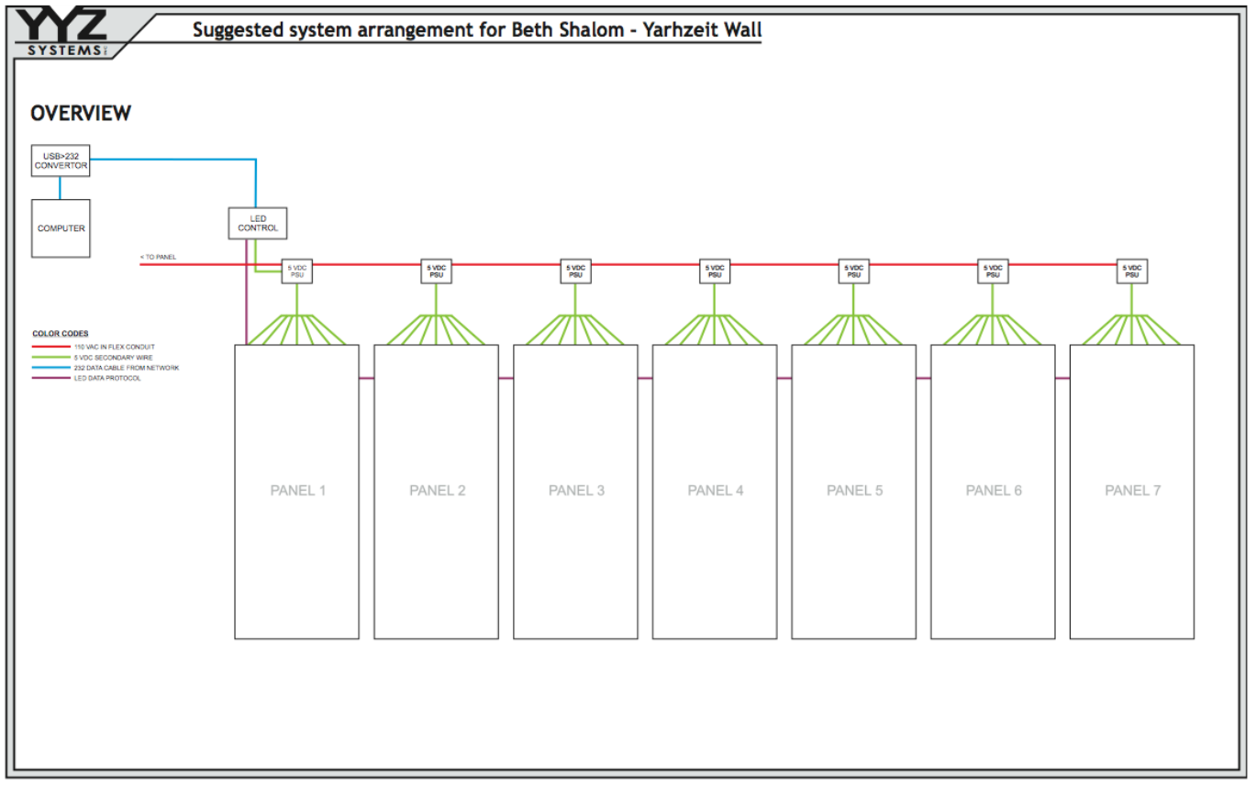

Yahrzeit Controller
The current Yahrzeit Controller is an Arduino Uno R4 Minima stack with an Ethernet shield and a custom pixel-interface shield. It replaces the original v1 8051-based controller, the separate serial-to-Ethernet bridge used in the original installation, and the v2 Arduino Mega controller used in the 2015 refresh.
The Yahrzeit Server communicates with the controller over Ethernet using a simple text command protocol. The controller maintains the LED wall state, maps logical wall/panel positions to the physical pixel chain, and refreshes the LED array behind the glass panels.
During normal operation, synagogue staff do not need to interact with the controller directly. Controller diagnostics and firmware maintenance are engineering/service tasks.

Yahrzeit Server / Appliance System
There are three layers of Yahrzeit software:
- The browser-based management software, used by synagogue staff to maintain memorial records, configure synagogue policy, view status, and run reports. This runs on the Yahrzeit Server / Appliance and is based on the standard Linux/Apache/PHP web application stack.
- The background automation software, which runs scheduled Yahrzeit and Yizkor operations and sends the required display commands to the controller. This software runs automatically during normal operation.
- The embedded controller firmware, which runs on the Arduino-based Yahrzeit Controller. This firmware maintains the LED wall state and drives the LED array at the hardware level.

The current Yahrzeit Server / Appliance is a dedicated Linux-based computer located in the synagogue office or other designated equipment location. See section 27-8 Yahrzeit Server, for the appliance address, login/service notes, backups, scheduled operation, and maintenance procedures.

The Yahrzeit Server’s Browser User Interface
Normal operation of the Yahrzeit Server is through its browser-based user interface. Synagogue staff use these pages to view wall status, maintain memorial records, configure synagogue policy, and run reports or controlled wall operations.
The complete user interface is described in section 27-8 Yahrzeit Server. The installed browser address should be recorded there after the server/appliance is configured on the synagogue network.
The sample pages below show the wall status/controller page and the Minhag configuration page.

- Yahrzeit Controller: This page summarizes the current state of the Yahrzeit Wall and provides links to related status, configuration, and maintenance pages.

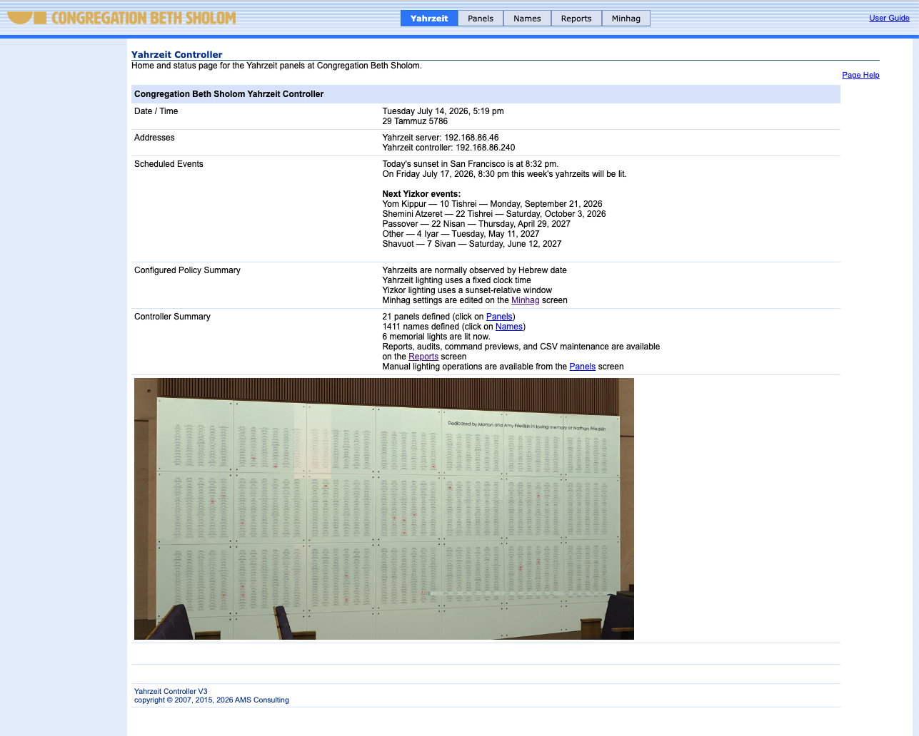

- Minhag: This page configures the synagogue-specific customs and observances used by the Yahrzeit and Yizkor lighting schedule.

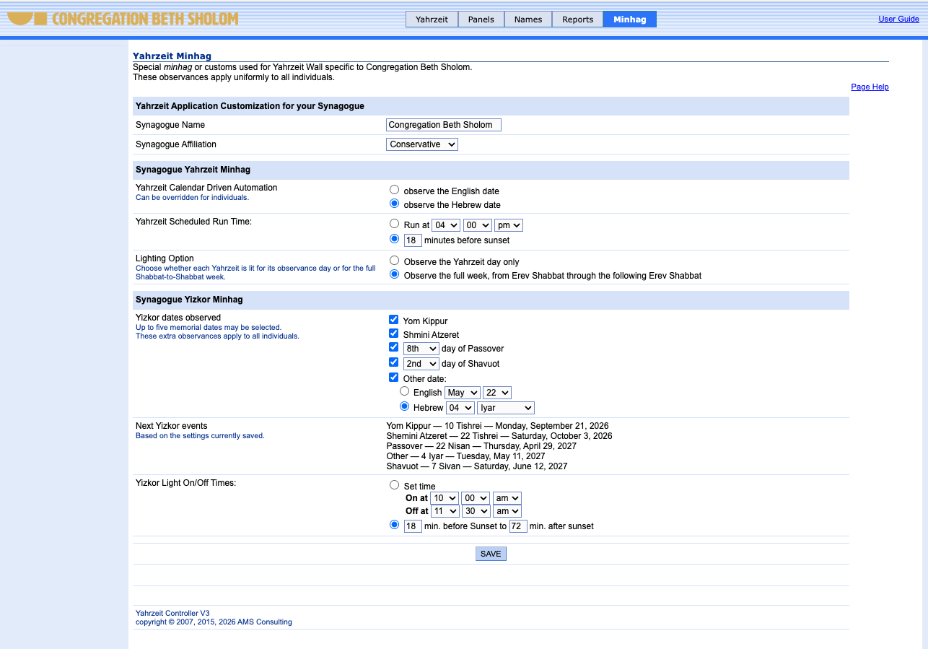

Related Documentation
This overview describes the purpose and major components of the Yahrzeit Wall. More detailed information is maintained in the following House Manual sections:
- 27-7 Yahrzeit Panels – glass panels, panel layout, physical panel maintenance, and panel repair/reprint information.
- 27-8 Yahrzeit Server – server/appliance operation, browser access, scheduled operation, backups, network addresses, and maintenance procedures.
- 27-3 Low Voltage Room – building electronics location and infrastructure, where applicable.
- 27-4 Networking – building network information, where applicable.
Engineering source files, firmware, hardware drawings, and appliance software are maintained in the public Yahrzeit source repository on GitHub. The installed appliance normally contains a sparse checkout under /home/allan/src/yahrzeit, with the web appliance in /home/allan/src/yahrzeit/yahrzeit_site-v3. The full project tree is available from the public GitHub repository referenced by that checkout. These files are intended for service, repair, refresh, and future engineering work, not for normal synagogue staff operation.

